Project 3:
Binary Tree
& Graph

Course: Data Structure Lab( Friday 14:00 - 16:35 )
Student Name: CEN WEIQIANG ANDREW
Student ID Number: 2018059131
Project 3: Binary Tree and Graph

Experiment 1: Binary Tree

Section 1: Introduction

This experiment has the purpose to help us to master all the basic operations of binary trees.
BINARY TREES.-
A tree whose elements have at most 2 children is called a binary tree. Since each element in a binary tree can have only 2 children, we typically name them the left and right child.
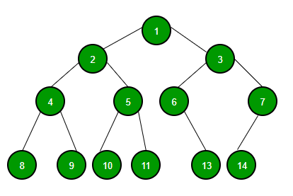

A Binary Tree node contains following parts.

- Data
- Pointer to left child
- Pointer to right child

Unlike linear data structures (Array, Linked List, Queues, Stacks, etc) which have only one logical way to traverse them, trees can be traversed in different ways. Following are the generally used ways for traversing trees.

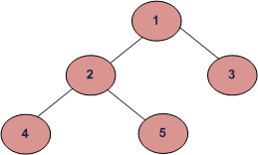
Depth First Traversals:
(a) Inorder (Left, Root, Right) : 4 2 5 1 3
(b) Preorder (Root, Left, Right) : 1 2 4 5 3
(c) Postorder (Left, Right, Root) : 4 5 2 3 1
Breadth First or Level Order Traversal : 1 2 3 4 5

Section 2:Algorithms Specification

Input the pre-order traversal sequence of a binary tree, where * represents virtual node (i.e. the node does not exist, NULL link), for example ABD***CE**F**. (Also consider the example: ABC*D*E***F**.)
Complete the following tasks:

- Use the linked representation to represent the inputted tree.
Following is an example program of creating a binary tree recursively base on the inputted pre-order traversal sequence. Modify the program to create a binary tree iteratively .

Use linked representation as the storage structure of a binary tree. The data type of BinTree (binary tree) is defined as bellow:

typedef struct node{
char data;
struct node *lchild,*rchild;
}BinTNode; //define the data type of the node
typedef BinTNode *BinTree;

BinTree CreatBinTree(void){
BinTree T;
char ch;
if((ch=getchar())=='*')
return(NULL); /*input is ‘*’，return null vector*/
else{
T= (BinTNode *)malloc(sizeof(BinTNode)); /*create a node*/
T->data=ch;
T->lchild=CreatBinTree(); /*create the left subtree*/
T->rchild=CreatBinTree(); /*create the right subtree*/
return(T);
}
}
- Program to traverse the binary tree and output the traversal sequences with breadth-first traversals.
- Program to count the hight of the tree, the number of the leaves in the tree and the total number of the nodes in the tree
- Destroy binary tree.
During this experiment I created codes for different traversals and a specific one to count the height, the leaf and the nodes of the tree.
Section 3:Test results
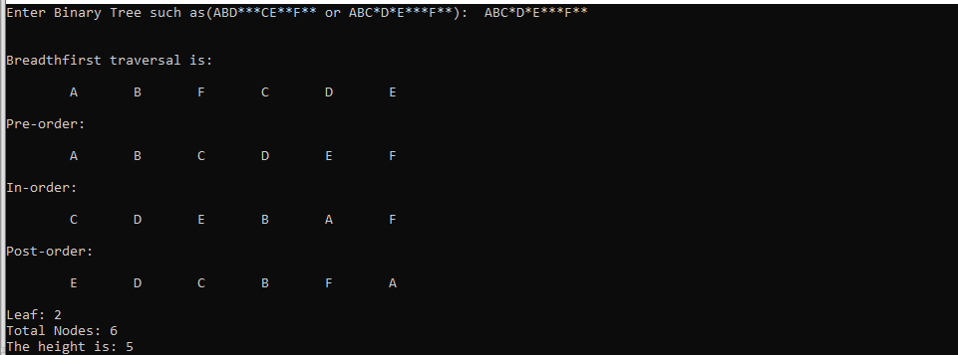
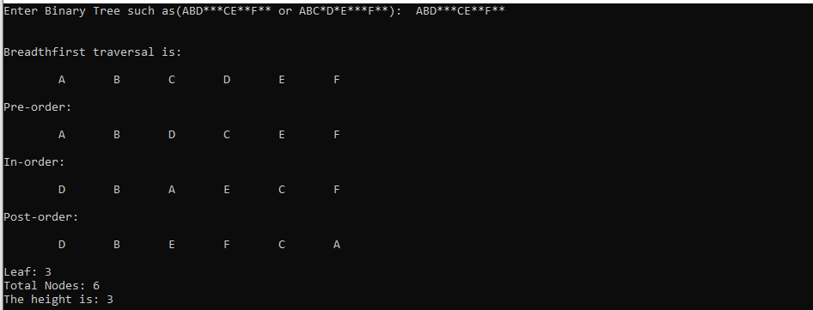

Section 4:Analysis and Comments

Time Complexity: O(n)

I really found it a lot more difficult than the first one, and after all my effort, this still with some error that I can not know is. For example when I input a parenthesis, etc.
And really want you, my dear teacher to read this. Give us easier experiment please.
During this experiment, we used stack but from the beginning I did it with array. I have to say that with array is a lot easier than Stacks. Cause using stacks I need to create those functions more complicated. And the more complicate is the program the more possibles errors appears. This experiment can be separated be two part, one to change the infix expression to postfix expression, this part is the easiest part of the experiment. And the second part is to evaluate the postfix expression, this is really hard.
During this experiment, I discovered more functions and libraries, such are very useful and helpful.
This experiment is quite funny, cause how the expression changed from infix to postfix, not only theory in class. We make it, this show me how it works in code.

Section5:Source code(in C language)

#include<stdio.h>
#include<stdlib.h>

int Nodecount = 0;
int Leavecount = 0;

struct Node;
typedef struct Node * Nodeptr;
typedef Nodeptr Binarytree;

struct Node
{
char element;
Binarytree Leftchild;
Binarytree Rightchild;
};

typedef struct qNode
{
Binarytree data;
struct qNode * next;
}QueueNode;

typedef struct
{
QueueNode * qFront;
QueueNode * qRear;
}LinkedQueue;

void InitializeLink(LinkedQueue * LinkedQueue)
{
LinkedQueue -> qFront = (QueueNode *)malloc(sizeof(QueueNode));
LinkedQueue -> qFront -> next = NULL;
LinkedQueue -> qRear = LinkedQueue -> qFront;
}

void Enqueue(LinkedQueue * LinkedQueue, Binarytree T)
{
if(LinkedQueue -> qFront -> next == NULL)
{
LinkedQueue -> qFront -> next = LinkedQueue -> qRear;
}
QueueNode * node=(QueueNode *)malloc(sizeof(QueueNode));
node -> data = T;
node -> next = NULL;
LinkedQueue -> qRear -> next = node;
LinkedQueue -> qRear = node;
}

Binarytree Dequeue(LinkedQueue * LinkedQueue)
{
Binarytree treenode = NULL;
if(LinkedQueue -> qFront == LinkedQueue -> qRear)
return treenode;
treenode = (Nodeptr*)malloc(sizeof(Nodeptr));
QueueNode * node = (QueueNode*)malloc(sizeof(QueueNode));
node=LinkedQueue -> qFront -> next;
treenode = node -> data;
LinkedQueue -> qFront -> next = node -> next;
if(LinkedQueue -> qFront -> next == node)
{
LinkedQueue -> qRear = LinkedQueue -> qFront;
}
free(node);
return treenode;
}

int IsEmpty(LinkedQueue * LinkedQueue)
{
if(LinkedQueue -> qFront -> next == NULL)
return 1;
else return 0;
}

Binarytree CreateBinaryTree()
{
Binarytree T;
int input;
if((input = getchar()) == '*')
return NULL;
else
{
T = (Nodeptr *)malloc(sizeof(Nodeptr));
if(T == NULL)
printf("Error! Out of Space!");
T -> element = input;
Nodecount++;
T -> Leftchild = CreateBinaryTree();
T -> Rightchild = CreateBinaryTree();
return T;
}
}

void Breadthfirst(Binarytree);
void Preorder(Binarytree);
void Inorder(Binarytree);
void Postorder(Binarytree);
void Leaf(Binarytree);
int Height(Binarytree T);

int main()
{
printf("Enter Binary Tree such as(ABD***CE**F** or ABC*D*E***F**): ");
Binarytree T = CreateBinaryTree();

printf("\n\nBreadthfirst traversal is:\n\n");
Breadthfirst(T);
printf("\n\nPre-order:\n\n");
Preorder(T);
printf("\n\nIn-order:\n\n");
Inorder(T);
printf("\n\nPost-order:\n\n");
Postorder(T);
Leaf(T);
printf("\n\nLeaf: %d",Leavecount);
printf("\nTotal Nodes: %d",Nodecount);
printf("\nThe height is: %d",Height(T));
free(T);
return 0;
}

void Breadthfirst(Binarytree T)
{
LinkedQueue queue;
InitializeLink(&queue);
Enqueue(&queue,T);
while(!IsEmpty(&queue))
{
Binarytree node = Dequeue(&queue);
printf("\t%c",node -> element);
if(node -> Leftchild != NULL)
{
Enqueue(&queue, node -> Leftchild);
}
if(node -> Rightchild != NULL)
{
Enqueue(&queue, node -> Rightchild);
}
}
}

void Preorder(Binarytree T)
{
if(T)
{
printf("\t%c",T -> element);
Preorder(T -> Leftchild);
Preorder(T -> Rightchild);
}
}
void Inorder(Binarytree T)
{
if(T){
Inorder(T -> Leftchild);
printf("\t%c",T -> element);
Inorder(T -> Rightchild);
}
}
void Postorder(Binarytree T)
{
if(T){
Postorder(T -> Leftchild);
Postorder(T -> Rightchild);
printf("\t%c",T -> element);
}
}
void Leaf(Binarytree T)
{
if(T){
if(T -> Leftchild == NULL && T -> Rightchild == NULL)
Leavecount++;
else
{
Leaf(T -> Leftchild);
Leaf(T -> Rightchild);
}
}
}
int Height(Binarytree T)
{
if(T == NULL)
return 0;
else
{
int m = Height (T -> Leftchild );
int n = Height(T -> Rightchild);
return (m > n) ? (m+1) : (n+1);
}
}

Experiment 2: Basic Operations on Graph

Section 1: Introduction

The objective of this experiment is:
(1) Grasp the basic methods to represent a graph
(2) Grasp the BFS method to traverse a graph

Section 2:Algorithms Specification

ADT of Graph:
Structure of Directed Graph is an object composed of a nonempty set of vertices and a set of undirected edges, where each edge is a pair of vertices

Functions: for all graph ∈Graph, v, v1 and v2 ∈ Vertices
Graph Create(), return an empty graph
Graph InsertVertex(Graph, v), return a graph with v inserted. v has no incident edge.
Graph InsertEdge(Graph, v1,v2), return a graph with new edge between v1 and v2
Graph DeleteVertex(Graph, v), return a graph in which v and all edges incident to it are removed
Graph DeleteEdge(Graph, v1, v2), return a graph in which the edge (v1, v2) is removed
Boolean IsEmpty(Graph), if the graph is empty return TRUE else return FALSE

Finish the following tasks:
- Use adjacency list to represent graphs and define the corresponding abstract data type.
- Realize all the above functions for the graph ADT.
- Input a graph in form of strings as described below. Base on the input, generate an object to represent the graph.
- Realize and output the topological ordering of the graph.

Input
The input consists of several test cases. Each test case contains two lines.
The first line contains the vertex set V. The second line contains edge set E.
A single 0 indicate the end of the input.

Output
The output is one the topological ordering sequences of the graph.

Sample input
A B C D E F
A B, A D, C F, C B, E A, E B, F E 0

Sample output
CFEABD

During this experiment I wrote all the functions such as insert vertex , insert edge and after that I created a main with cases that allowed the user to chose what function to apply.
To test the code, I mean to run it you should insert a vertex first and then an edge.

Section 3:Test results
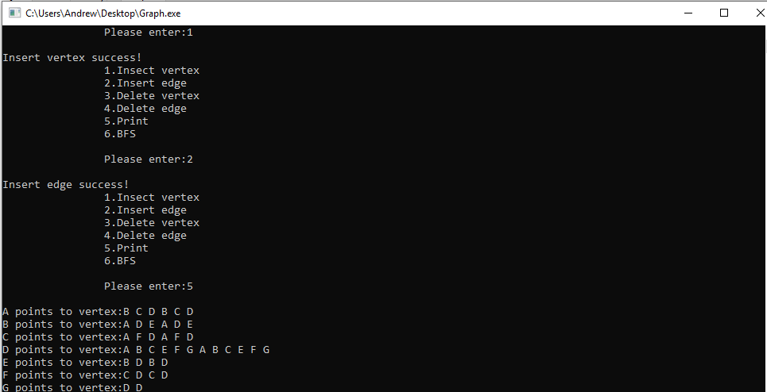

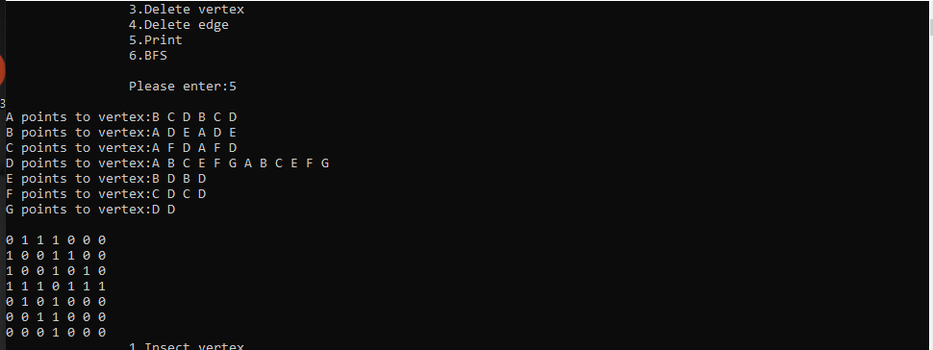

Section 4:Analysis and Comments

Time Complexity: O(|V|), O(|E|)
In this project we have two experiments, from the beginning I found the first one super hard, thinking that it is the most difficult part, but when I reached the second part, the Graph one is extremely hard, how I suffer for this.

Section5:Source code(in C language)

#include<stdio.h>
#include<malloc.h>
#define max 10

typedef struct Edge
{
int posi_vex;
struct Edge *next_edge;
}edge;

typedef struct Ver
{
int flag;
int posi;
char data;
edge *first_edge;
}ver;

typedef struct Graph
{
int vernum;
int edgenum;
ver gra[max];
}graph;

typedef struct Matrix
{
char ver[max];
int vernum;
int edgenum;
int matri[max][max];
}matrix;

int IsEmpty(graph *g)
{
if(g->vernum==0)
return 1;
return 0;
}

graph* Create()
{
graph *g;
g=(graph*)malloc(sizeof(graph));
g->edgenum=0;
g->vernum=0;

return g;
}
matrix* create()
{
matrix *g;
g=(matrix*)malloc(sizeof(matrix));
g->vernum=0;
g->edgenum=0;
return g;
}

void InsertVertex(graph* g, char v)
{
g->gra[g->vernum].flag=0;
g->gra[g->vernum].data=v;
g->gra[g->vernum].posi=g->vernum;
g->gra[g->vernum].first_edge=NULL;
g->vernum++;
}
void insertvertex(matrix *g, char v)
{
g->ver[g->vernum]=v;
g->vernum++;
}

void InsertEdge(graph *g, ver *v1, ver *v2)
{
edge *node1=(edge*)malloc(sizeof(edge));
node1->next_edge=NULL;
node1->posi_vex=v2->posi;

if(v1->first_edge==NULL)
v1->first_edge=node1;
else
{
edge *e=v1->first_edge;

while(e->next_edge!=NULL)
e=e->next_edge;
e->next_edge=node1;
}

edge *node2=(edge*)malloc(sizeof(edge));
node2->next_edge=NULL;
node2->posi_vex=v1->posi;

if(v2->first_edge==NULL)
v2->first_edge=node2;
else
{
edge *e=v2->first_edge;

while(e->next_edge!=NULL)
e=e->next_edge;
e->next_edge=node2;
}
g->edgenum++;
}
void insertedge(matrix *g, int a, int b)
{
g->matri[a][b]=1;
g->matri[b][a]=1;
g->edgenum++;
}

void DeleteEdge(graph* g, ver *v1, ver *v2)
{
edge *e, *temp, *k;
int i;

e=(edge*)malloc(sizeof(edge));
k=(edge*)malloc(sizeof(edge));

e=v1->first_edge;
if(e->posi_vex==v2->posi)
{
v1->first_edge=e->next_edge;
free(e);
}
else
{
while(e->posi_vex!=v2->posi)
{
temp=e;
e=e->next_edge;
}
temp->next_edge=e->next_edge;
free(e);
}

k=v2->first_edge;
if(k->posi_vex==v1->posi)
{
v2->first_edge=k->next_edge;
free(k);
}
else
{
while(k->posi_vex!=v1->posi)
{
temp=k;
k=k->next_edge;
}
temp->next_edge=k->next_edge;
free(k);
}

g->edgenum--;
}
void deleteedge(matrix* g, int a, int b)
{
g->matri[a][b]=0;
g->matri[b][a]=0;

g->edgenum--;
}

void DeleteVertex(graph* g, ver *v)
{
int x=v->posi, i;
edge *e;
while(v->first_edge!=NULL)
DeleteEdge(g, v, &g->gra[v->first_edge->posi_vex]);
printf("\n");

for(i=0;i<g->vernum;i++)
{
e=g->gra[i].first_edge;
while(e!=NULL)
{
if(e->posi_vex>x)
e->posi_vex--;
e=e->next_edge;
}
}
for(i=x;i<(g->vernum-1);i++)
{
g->gra[i].first_edge=g->gra[i+1].first_edge;
g->gra[i].posi=g->gra[i+1].posi-1;
g->gra[i].data=g->gra[i+1].data;
}
g->vernum--;
}
void deletevertex(matrix* g, int a)
{
int i, j;
for(i=0;i<g->vernum;i++)
if(g->matri[a][i]==1)
deleteedge(g, a, i);
for(i=a;i<(g->vernum-1);i++)
g->ver[i]=g->ver[i+1];
for(i=0;i<(g->vernum-1);i++)
for(j=a;j<(g->vernum-1);j++)
g->matri[i][j]=g->matri[i][j+1];
for(i=a;i<(g->vernum-2);i++)
for(j=0;j<(g->vernum-1);j++)
g->matri[i][j]=g->matri[i+1][j];
g->vernum--;
}

void Print_Graph(graph* g)
{
edge *no;
int i;
for(i=0;i<g->vernum;i++)
{
printf("%c points to vertex:",g->gra[i].data);
no=g->gra[i].first_edge;
while(no!=NULL)
{
printf("%c ", g->gra[no->posi_vex].data);
no=no->next_edge;
}
printf("\n");
}
}
void print_graph(matrix* g)
{
int i,j;

for(i=0;i<g->vernum;i++)
{
for(j=0;j<g->vernum;j++)
printf("%d ",g->matri[i][j]);
printf("\n");
}
}

void enqueue(int que[], int posi, int tail)
{
que[tail]=posi;
}

int dequeue(int que[], int tail)
{
int temp=que[0], i;
for(i=0;i<tail;i++)
que[i]=que[i+1];
return temp;
}

int isempty(int tail)
{
if(tail==0)
return 0;
return 1;
}

void BFS(graph *g, int n)
{
int que[10], tail=0, i, x;
edge *e;
enqueue(que, g->gra[n].posi,tail);
g->gra[n].flag=1;
tail++;

while(isempty(tail))
{
x=dequeue(que, tail);
printf("%c ",g->gra[x].data);
tail--;
e=g->gra[x].first_edge;
if(g->gra[x].flag!=0)
while(e!=NULL)
{
if(g->gra[e->posi_vex].flag==0)
{
enqueue(que, g->gra[e->posi_vex].posi, tail);
g->gra[e->posi_vex].flag=1;
tail++;
}
e=e->next_edge;
}
}
}

int find(graph *g, char ch)
{
int i;
for(i=0;i<g->vernum;i++)
if(g->gra[i].data==ch)
return i;
printf("no found!!!\n\n");
main();
}

void menu()
{
printf(" 1.Insect vertex\n");
printf(" 2.Insert edge\n");
printf(" 3.Delete vertex\n");
printf(" 4.Delete edge\n");
printf(" 5.Print\n");
printf(" 6.BFS\n\n");
}

int main()
{
graph* ph;
matrix* pp;
ph=Create();
pp=create();
char data[]={'A','B','C','D','E','F','G'};
char edge[]={'A', 'B', 'A', 'C', 'A', 'D', 'B', 'D', 'B', 'E', 'C', 'F', 'C', 'D', 'D', 'E', 'D', 'F', 'D', 'G'};
char v, v1, v2,v3;
int choice, num1, num2, i, j, k;

while(1)
{

menu();

printf(" Please enter:");
scanf("\n%d",&choice);
printf("\n");
switch(choice)
{
case 1:
for(i=0;i<7;i++)
{
InsertVertex(ph, data[i]);
insertvertex(pp, data[i]);
}
for(i=0;i<pp->vernum;i++)
for(j=0;j<pp->vernum;j++)
pp->matri[i][j]=0;
printf("Insert vertex success!\n");
break;
case 2:
for(i=0;i<20;i=i+2)
{
j=find(ph, edge[i]);
k=find(ph, edge[i+1]);
InsertEdge(ph, &ph->gra[j], &ph->gra[k]);
insertedge(pp, j, k);
}
printf("Insert edge success!\n");
break;
case 3:
printf("Please enter vertex:");
scanf("\n%c",&v);
i=find(ph, v);
DeleteVertex(ph, &ph->gra[i]);
deletevertex(pp, i);

break;
case 4:
printf("Connected vertex1:");
scanf("\n%c",&v1);
printf("Connected vertex2:");
scanf("\n%c",&v2);
j=find(ph, v1);
k=find(ph, v2);
DeleteEdge(ph, &ph->gra[j], &ph->gra[k]);
deleteedge(pp, j, k);
break;
case 5:
if(!IsEmpty(ph))
{
Print_Graph(ph);
printf("\n");
print_graph(pp);
}
else
printf("Please enter vertex!\n");
break;
case 6:
for(i=0;i<ph->vernum;i++)
if(ph->gra[i].flag==0)
BFS(ph, i);
printf("\n");
for(i=0;i<ph->vernum;i++)
ph->gra[i].flag=0;
break;
}
}
return 0;
}

